CI & CD Setup

Naeem Ahmad

**App Service Plan**

We choose D1 Shared Plan which cost very less and we can maintain 10 resources in this Service Plan.

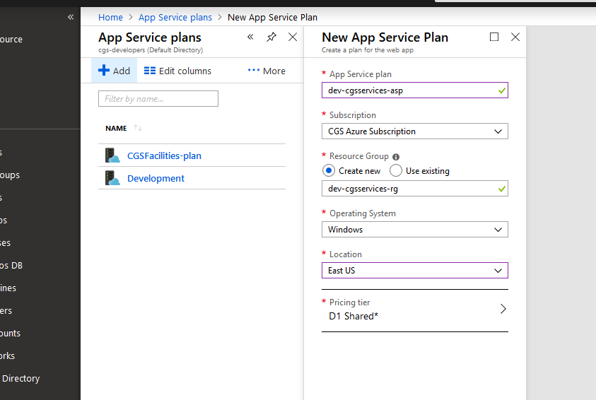

**Web App**

Setup web App’s as per requirements.

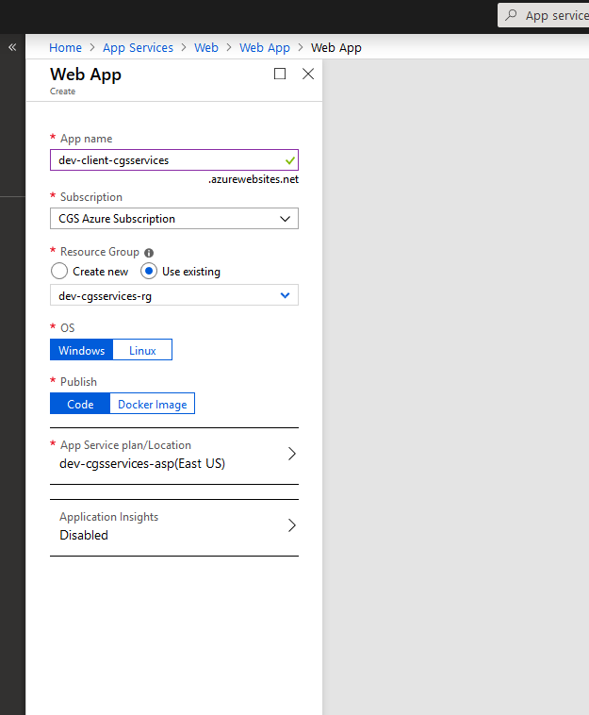

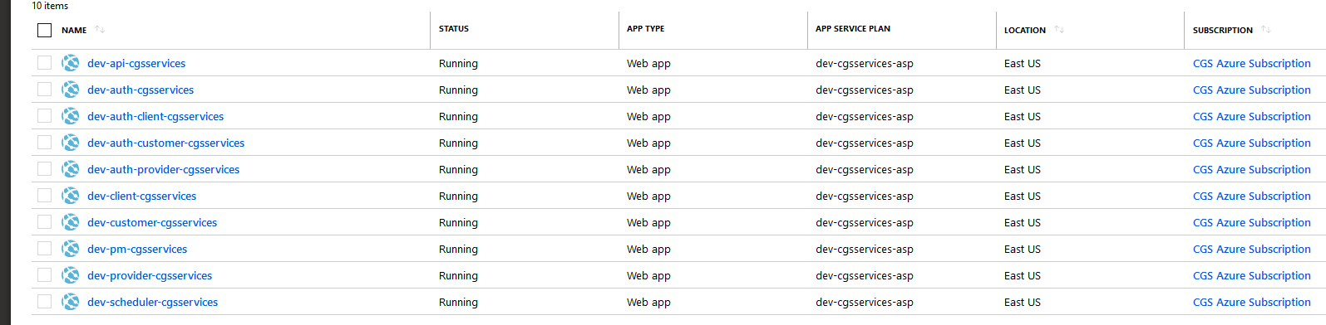

**Web App Details**

* **dev-api-cgsservices** (http://dev-api-cgsservices.azurewebsites.net)
* **dev-auth-cgsservices** (https://dev-auth-cgsservices.azurewebsites.net)
* **dev-auth-client-cgsservices** (https://dev-auth-client-cgsservices.azurewebsites.net)
* **dev-auth-customer-cgsservices** (https://dev-auth-customer-cgsservices.azurewebsites.net)
* **dev-auth-provider-cgsservices** (https://dev-auth-provider-cgsservices.azurewebsites.net)
* **dev-client-cgsservices** (http://dev-client-cgsservices.azurewebsites.net)
* **dev-customer-cgsservices** (http://dev-customer-cgsservices.azurewebsites.net)
* **dev-pm-cgsservices** (http://dev-pm-cgsservices.azurewebsites.net)
* **dev-provider-cgsservices** (http://dev-provider-cgsservices.azurewebsites.net)
* **dev-scheduler-cgsservices** (http://dev-scheduler-cgsservices.azurewebsites.net)

**VSTS**

<https://dev.azure.com/cgsoftwares0526/>

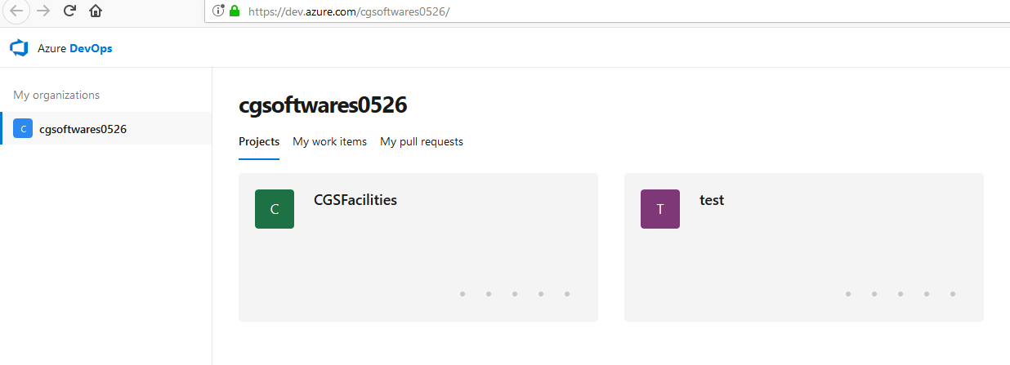

**For Continuous Integration(CI)**

When we click on Pipelines > Build Below page comes and not the one you have pasted in your documents# Screenshot for reference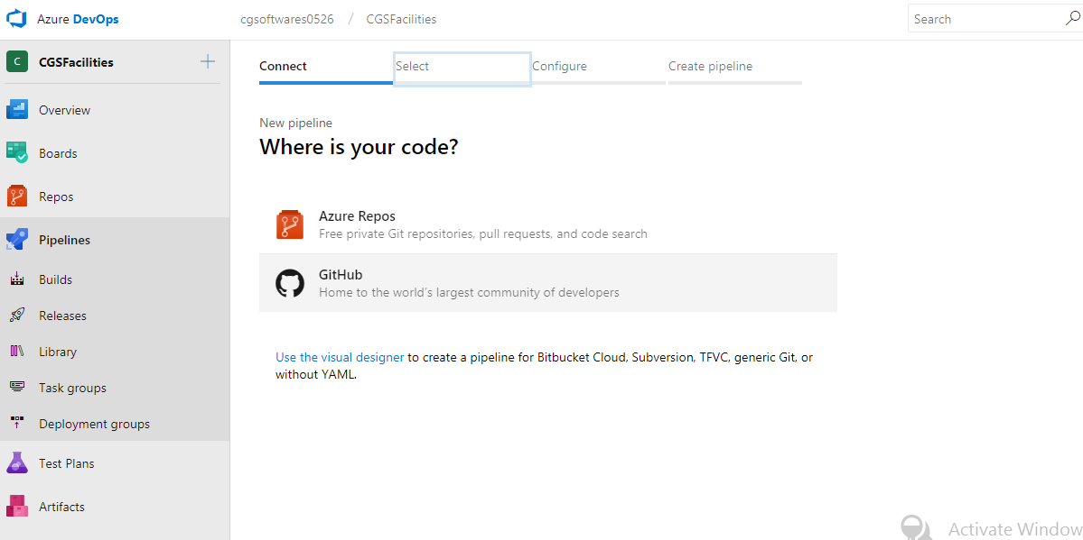

Please give step by step details on how we landed on below page for which you have pasted the screen shot. Please also give details about the clicks/options chosen so we get to the same page as you.

We Created New Build Pipeline for creating Continuous Integration (CI)

Select **TFVC** source and select our project repository. (Not clear how this came in front of user)

**Please go through the below URL for setup continuous-integration step by step:-**

<https://www.c-sharpcorner.com/article/continuous-integration-using-azure-devops-and-net-project/>

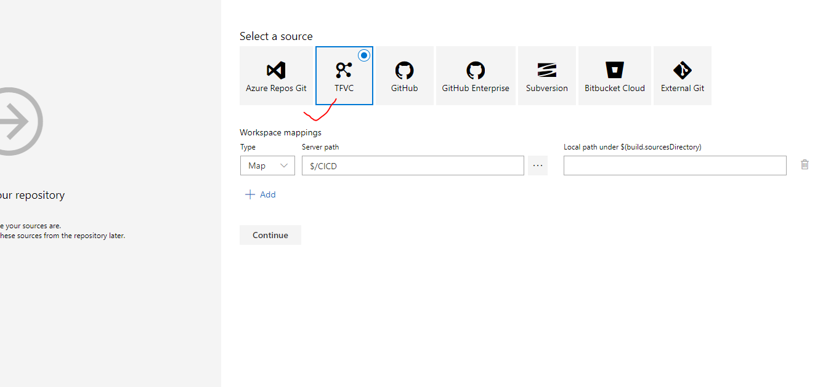

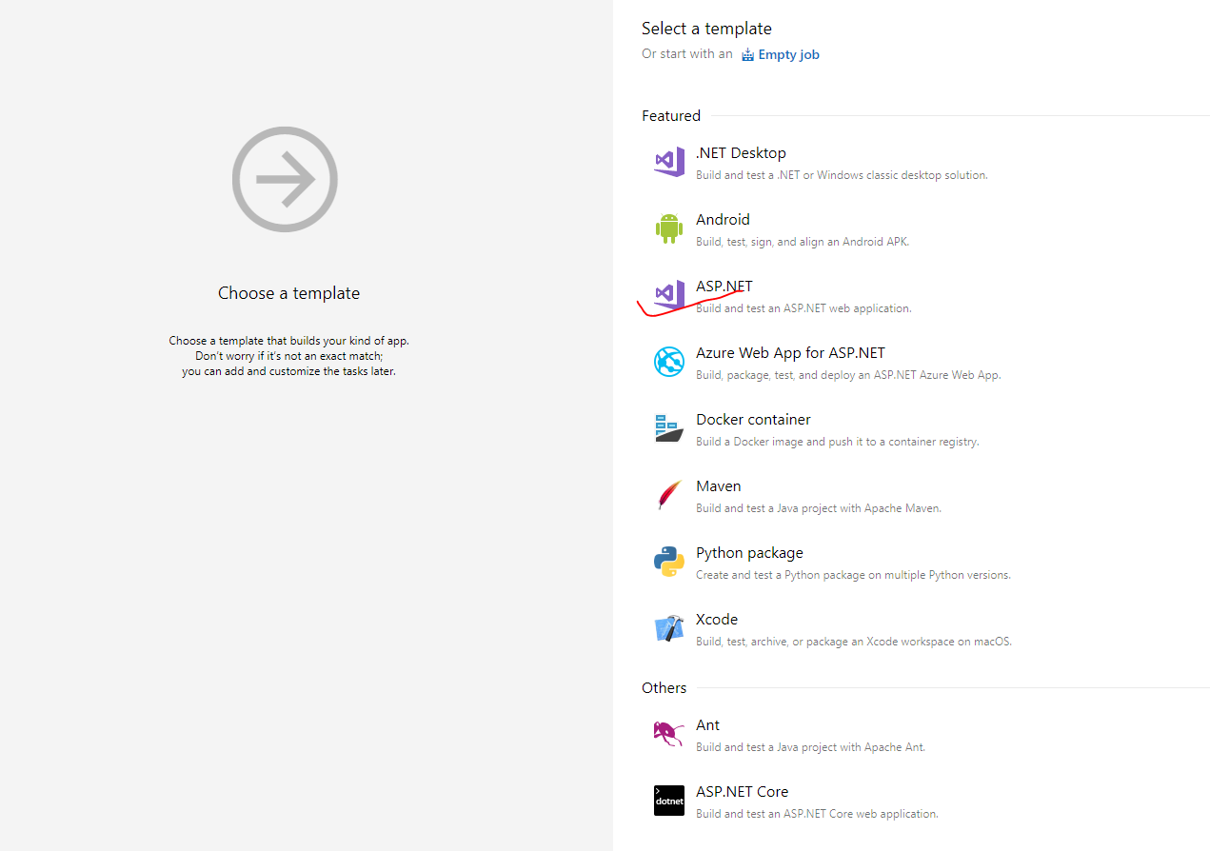We Select **Asp.Net template** for Asp.net MVC application project.

Select **Hosted VS2017** in Agent Pool for our build pipeline.

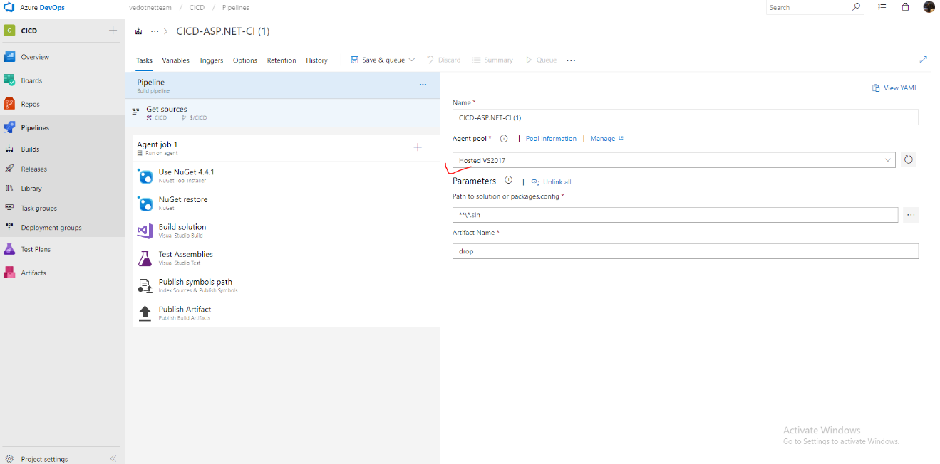

Select both **enable continuous integration** and **batch changes while a build is in Progress** for automatic build on any changes(commit) in repo**.**

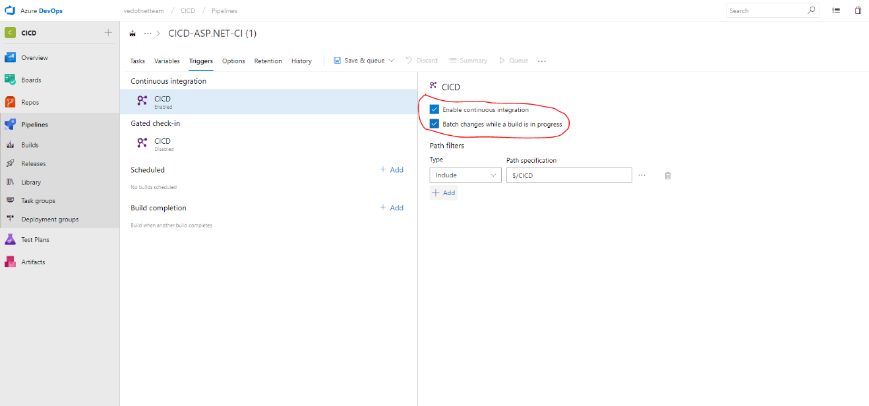

Missing information  
What menu to click to create the artifacts  
How we have created the Artifacts with steps and what are they. Please give more details

**Here you can get the detailed information of artifacts.**

<https://docs.microsoft.com/en-us/azure/devops/pipelines/artifacts/artifacts-overview?view=azdevops>

<https://www.c-sharpcorner.com/article/an-overview-of-artifacts-in-azure-devops/>

Created three Artifact: Facility Services, Facilities Auth and Scheduler for publish the three application in different containers: FacilitiesServicesdrop, FacilitiesAuth and Scheduler drop.

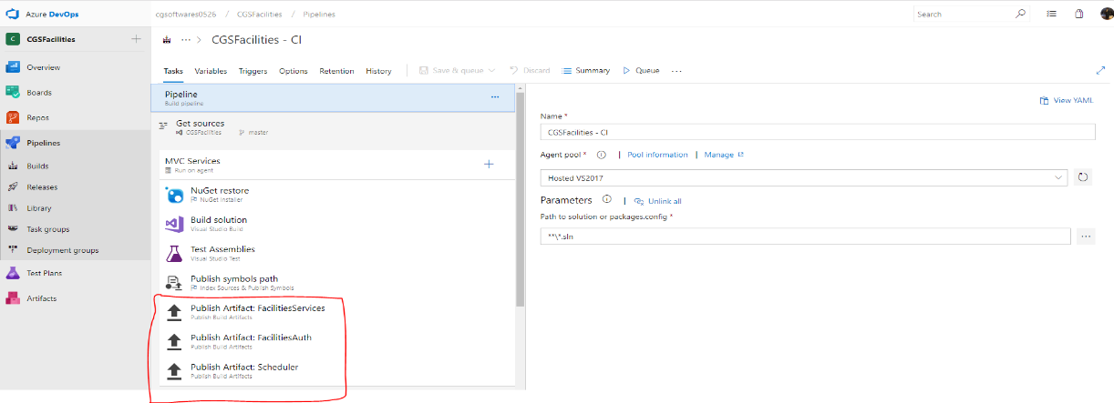

**For Creating Build and artifacts for angular applications:-**

Please give step by step demonstration about how exactly we started creating the task and how did we added components to run in that task. Please consider that the documentation should cover each and every step .

**Please go through below link for complete overview and step-by-step process for continuous integration in angular devops.**  
<https://medium.com/@flu.lund/setting-up-a-ci-pipeline-for-deploying-your-angular-application-to-azure-using-visual-studio-team-f686c8f190cf>

Add new agent job (Facilities Client) in pipeline which have task: **npm install**, **npm build** and **Publish Artifact**.

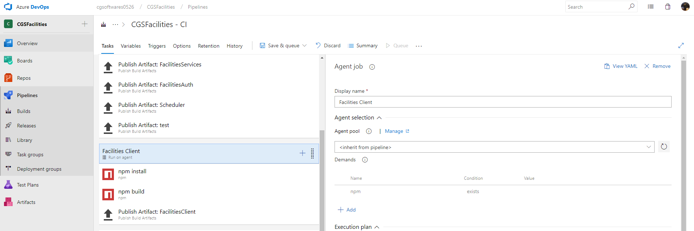

**Added same for facilities Customer, vendor and Pm Module**

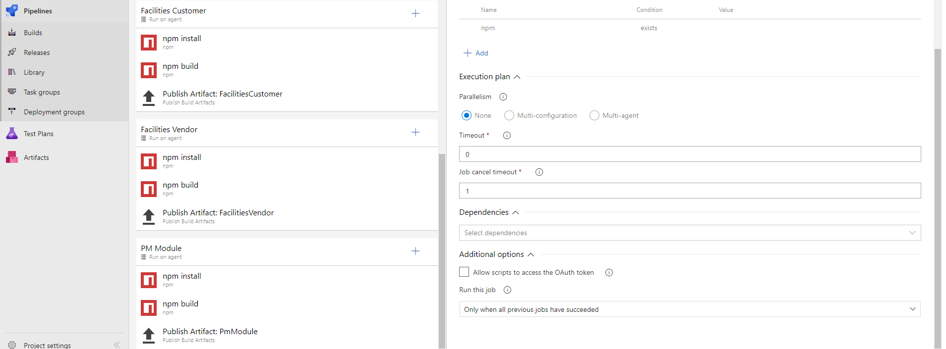

Now, we have 7 different artifacts container from one build and we can use them for deploying them to different app URL’s. These artifacts container are mentioned below:-

FacilitiesServicesdrop, FacilitiesAuth, Schedulerdrop, FacilitiesClientdrop, FacilitiesCustomerDrop,FacilitiesVendorDrop and PMModuledrop

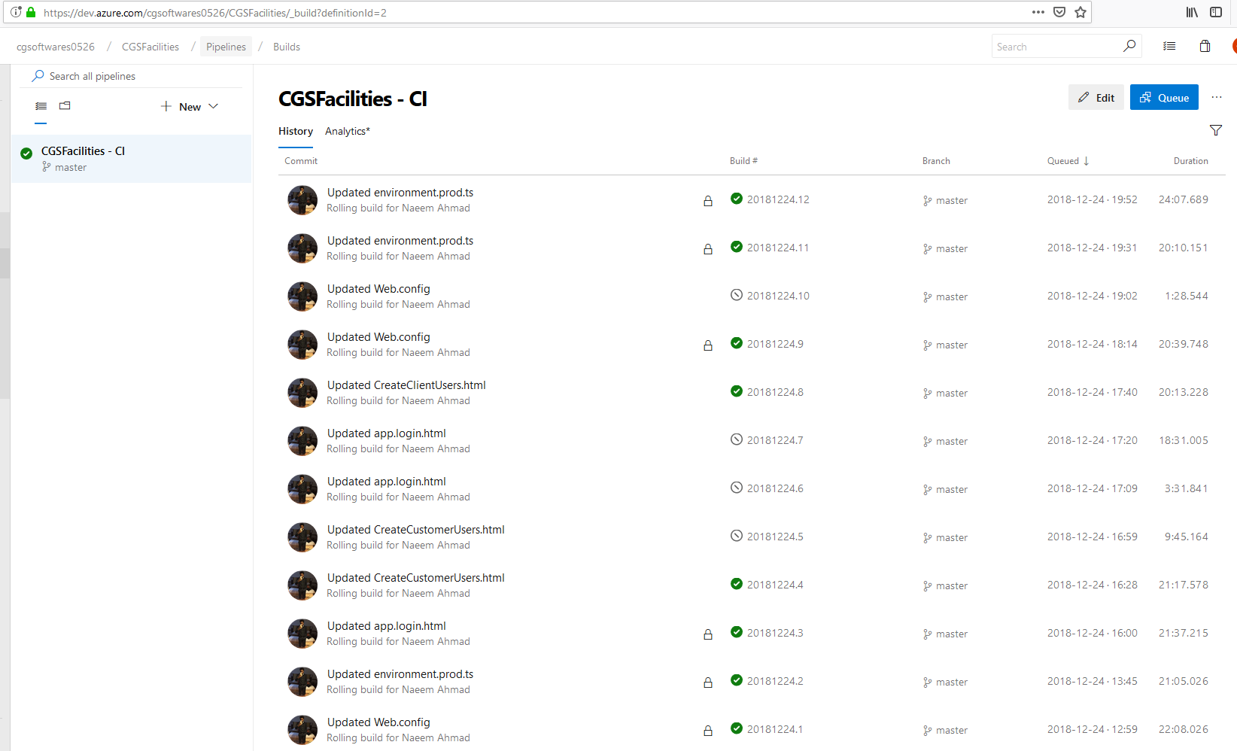

**For Continuous Deployment (CD)**

It is not clear as to how the user landed on this page  
Also on what option/click the left panel came upfront. Please give step by step information.

**Please go through below link for complete overview and step-by-step process for continuous development.**

<https://www.c-sharpcorner.com/article/azure-devops-for-web-development-cd-and-release-pipelines/>

https://www.c-sharpcorner.com/article/continuous-deployment-using-azure-devops-pipelines-and-net-project/

Created new release pipeline for Continuous Deployment (CD) and select **template Azure App Service Deploy**

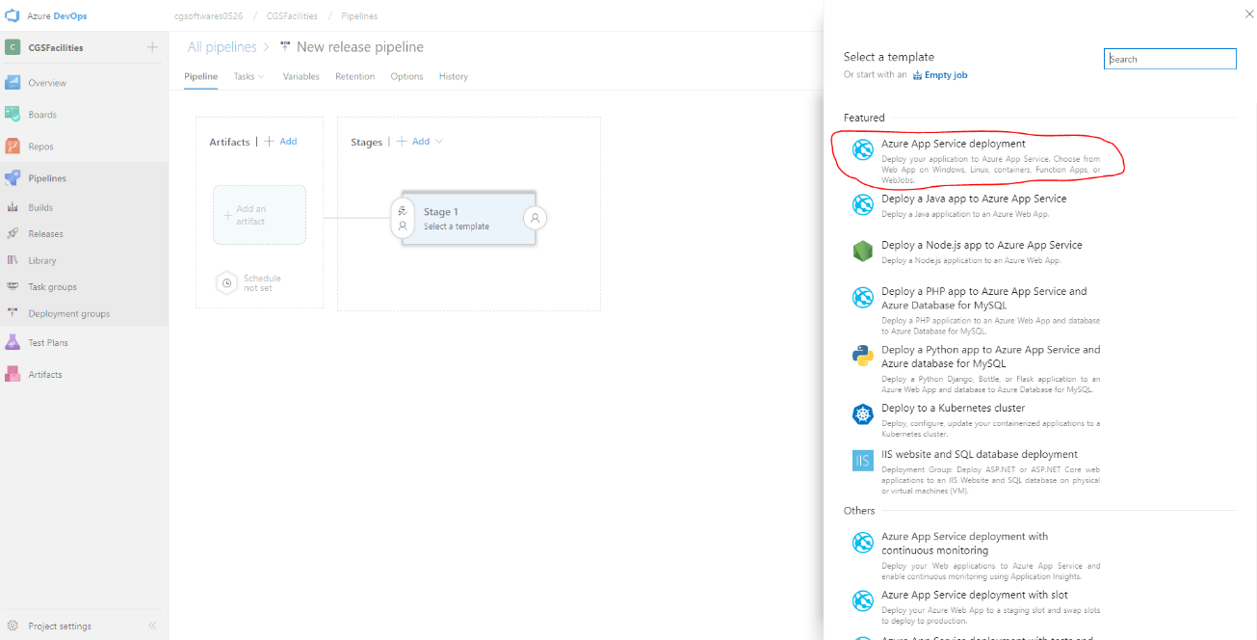

Add artifacts and select build pipeline

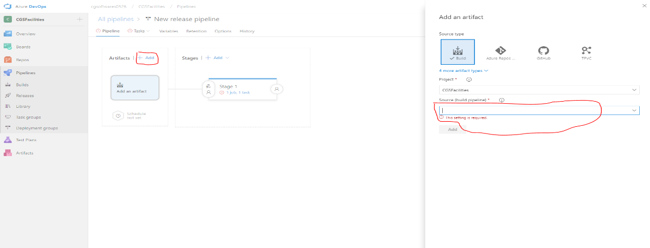

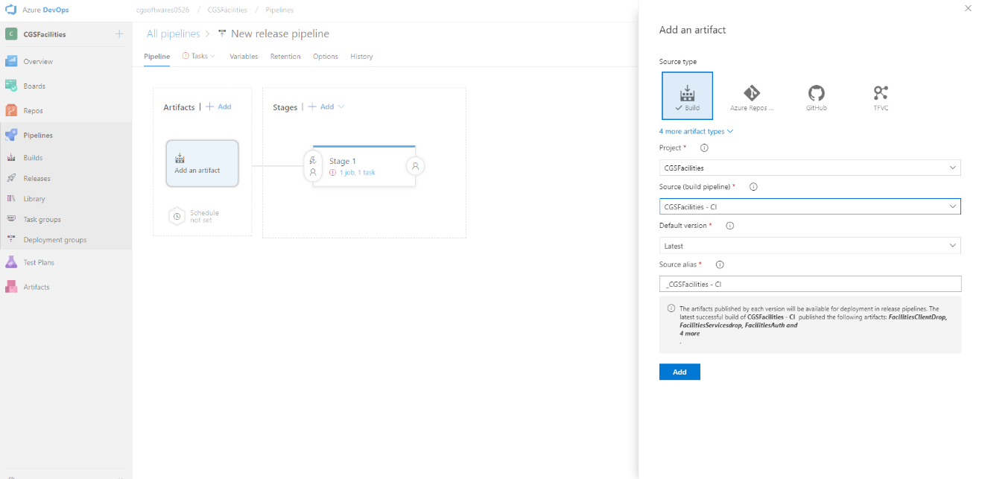

**Enable Continuous Deployment** for a release to be created each time a new build is available.

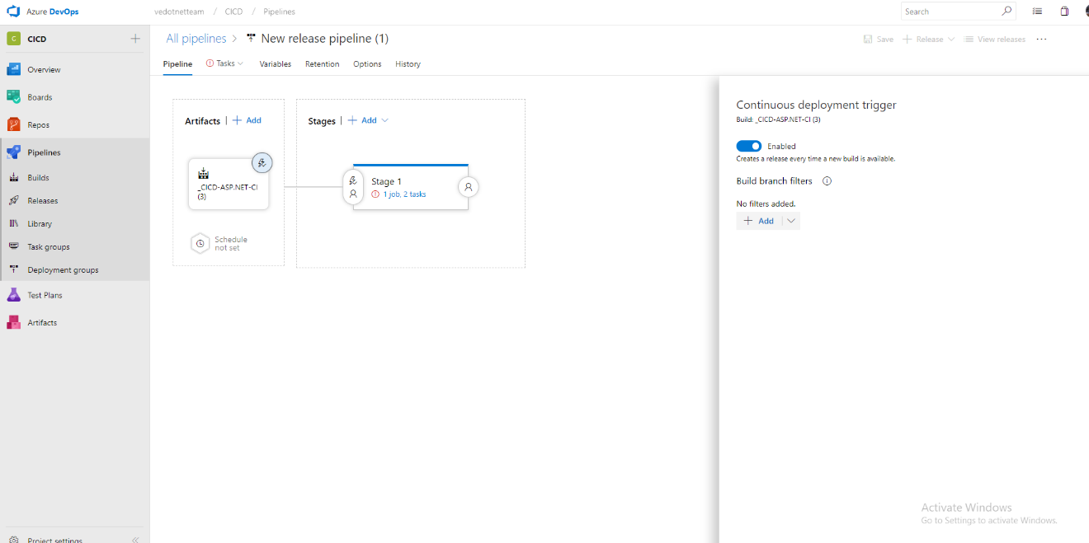

It is again not clear how to get to this stage. What menu to click and what option to put in. Please be more elaborative

**Please go through below link for complete overview and step-by-step process for continuous development.**

<https://www.c-sharpcorner.com/article/azure-devops-for-web-development-cd-and-release-pipelines/>

https://www.c-sharpcorner.com/article/continuous-deployment-using-azure-devops-pipelines-and-net-project/

Configure Azure App Service Deploy with subscription and app service name of target machine.

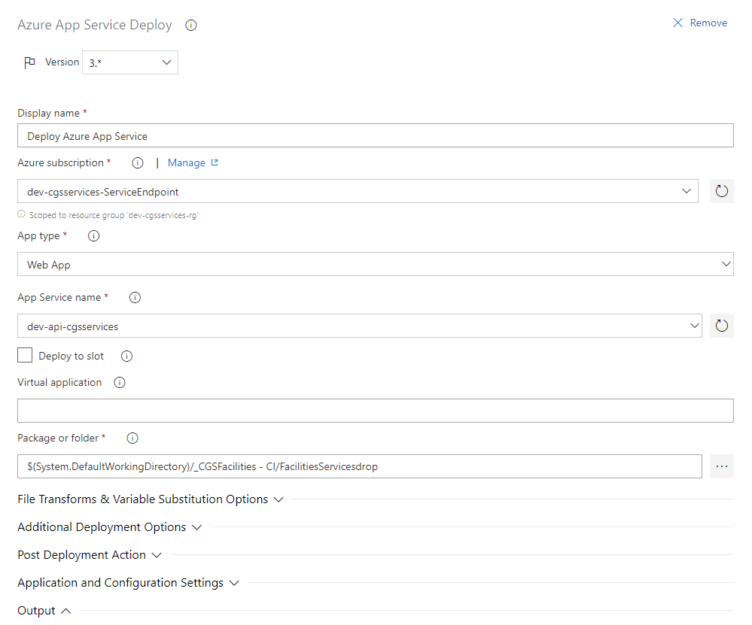

We have use 8 Azure **App Service Deploy** template with same configuration to deploy in different app service targets

Please specify each app and its template creation process.

**Please go through below link for Continuous Delivery with Azure Pipelines**

https://www.c-sharpcorner.com/article/continuous-release/

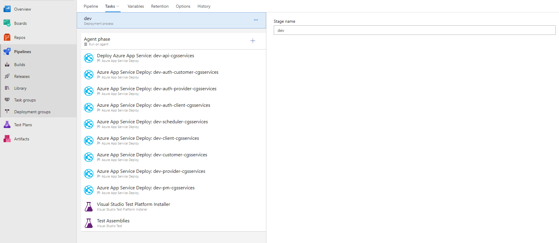

Created new release.

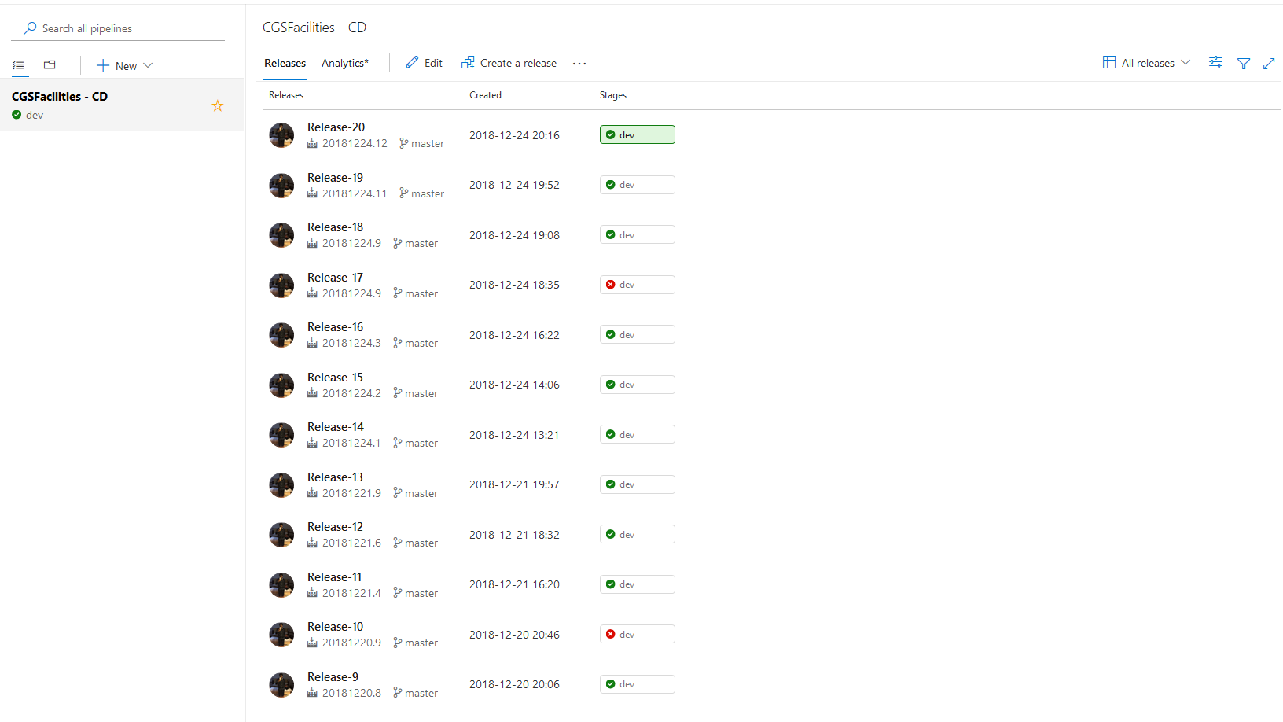

**Development**

* **dev-api-cgsservices** (http://dev-api-cgsservices.azurewebsites.net)
* **dev-auth-cgsservices** (https://dev-auth-cgsservices.azurewebsites.net)
* **dev-auth-client-cgsservices** (https://dev-auth-client-cgsservices.azurewebsites.net)
* **dev-auth-customer-cgsservices** (https://dev-auth-customer-cgsservices.azurewebsites.net)
* **dev-auth-provider-cgsservices** (https://dev-auth-provider-cgsservices.azurewebsites.net)
* **dev-client-cgsservices** (http://dev-client-cgsservices.azurewebsites.net)
* **dev-customer-cgsservices** (http://dev-customer-cgsservices.azurewebsites.net)
* **dev-pm-cgsservices** (http://dev-pm-cgsservices.azurewebsites.net)
* **dev-provider-cgsservices** (http://dev-provider-cgsservices.azurewebsites.net)
* **dev-scheduler-cgsservices** (http://dev-scheduler-cgsservices.azurewebsites.net)

**Pre-Production**

* **preprod-api-cgsservices** (http://preprod-api-cgsservices.azurewebsites.net)
* **preprod-auth-cgsservices** (https://preprod-auth-cgsservices.azurewebsites.net)
* **preprod-auth-client-cgsservices** (https://preprod-auth-client-cgsservices.azurewebsites.net)
* **preprod-auth-customer-cgsservices** (https://preprod-auth-customer-cgsservices.azurewebsites.net)
* **preprod-auth-provider-cgsservices** (https://preprod-auth-provider-cgsservices.azurewebsites.net)
* **preprod-client-cgsservices** (http://preprod-client-cgsservices.azurewebsites.net)
* **preprod-customer-cgsservices** (http://preprod-customer-cgsservices.azurewebsites.net)
* **preprod-pm-cgsservices** (http://preprod-pm-cgsservices.azurewebsites.net)
* **preprod-provider-cgsservices** (http://preprod-provider-cgsservices.azurewebsites.net)
* **preprod-scheduler-cgsservices** (http://preprod-scheduler-cgsservices.azurewebsites.net)

**Production**

* **prod-api-cgsservices** (http://prod-api-cgsservices.azurewebsites.net)
* **prod-auth-cgsservices** (https://prod -auth-cgsservices.azurewebsites.net)
* **prod-auth-client-cgsservices** (https://prod -auth-client-cgsservices.azurewebsites.net)
* **prod-auth-customer-cgsservices** (https://prod-auth-customer-cgsservices.azurewebsites.net)
* **prod-auth-provider-cgsservices** (https://prod-auth-provider-cgsservices.azurewebsites.net)
* **prod-client-cgsservices** (http://prod-client-cgsservices.azurewebsites.net)
* **prod-customer-cgsservices** (http://prod-customer-cgsservices.azurewebsites.net)
* **prod-pm-cgsservices** (http://prod-pm-cgsservices.azurewebsites.net)
* **prod-provider-cgsservices** (http://prod-provider-cgsservices.azurewebsites.net)
* **prod-scheduler-cgsservices** (http://prod-scheduler-cgsservices.azurewebsites.net)

**Approval Workflow**

After check-in code, CI start the build automatically

URL : <https://dev.azure.com/cgsoftwares0526/CGSFacilities/_build?definitionId=2>

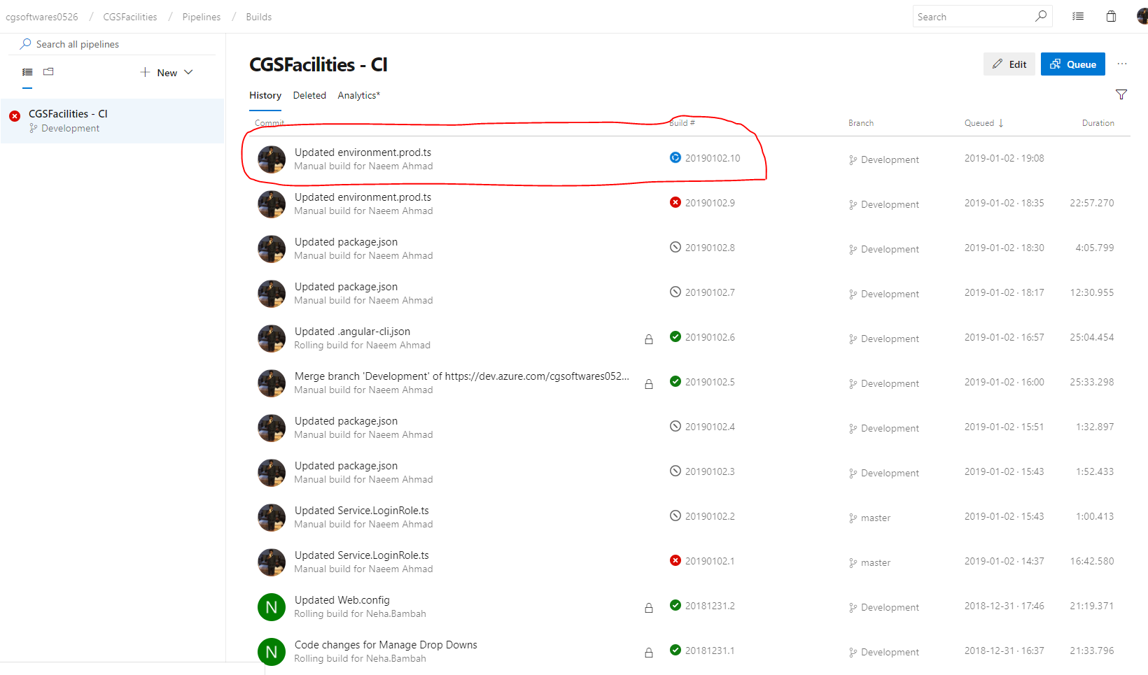

After build complete, deployment will started automatically on latest build

URL :<https://dev.azure.com/cgsoftwares0526/CGSFacilities/_release?view=mine&definitionId=1>

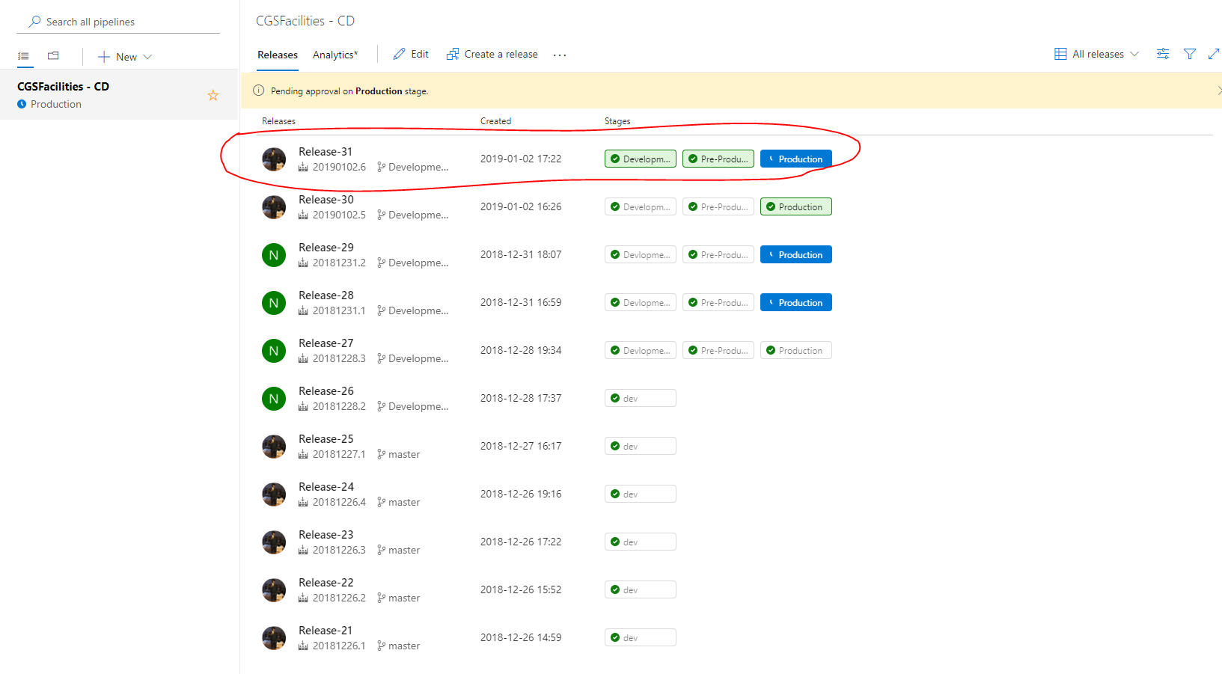

To see the continuous deployment, please click the release which is in processing

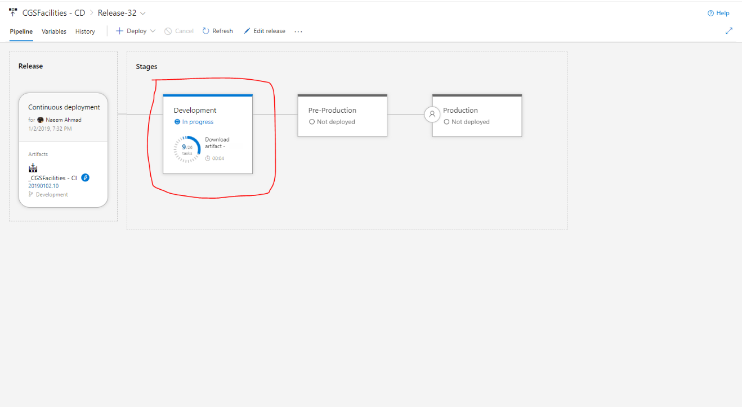

There are three stages in Release:-

**Development**

It will automatically triggered and deploy the apps on below mentioned urls

<http://dev-customer-cgsservices.azurewebsites.net>

<http://dev-client-cgsservices.azurewebsites.net>

<http://dev-provider-cgsservices.azurewebsites.net>

<http://dev-api-cgsservices.azurewebsites.net>

<http://dev-scheduler-cgsservices.azurewebsites.net>

<https://dev-auth-client-cgsservices.azurewebsites.net>

<https://dev-auth-customer-cgsservices.azurewebsites.net>

<https://dev-auth-provider-cgsservices.azurewebsites.net>

[https://dev-pm-cgsservices.azurewebsites.net](http://dev-pm-cgsservices.azurewebsites.net/)

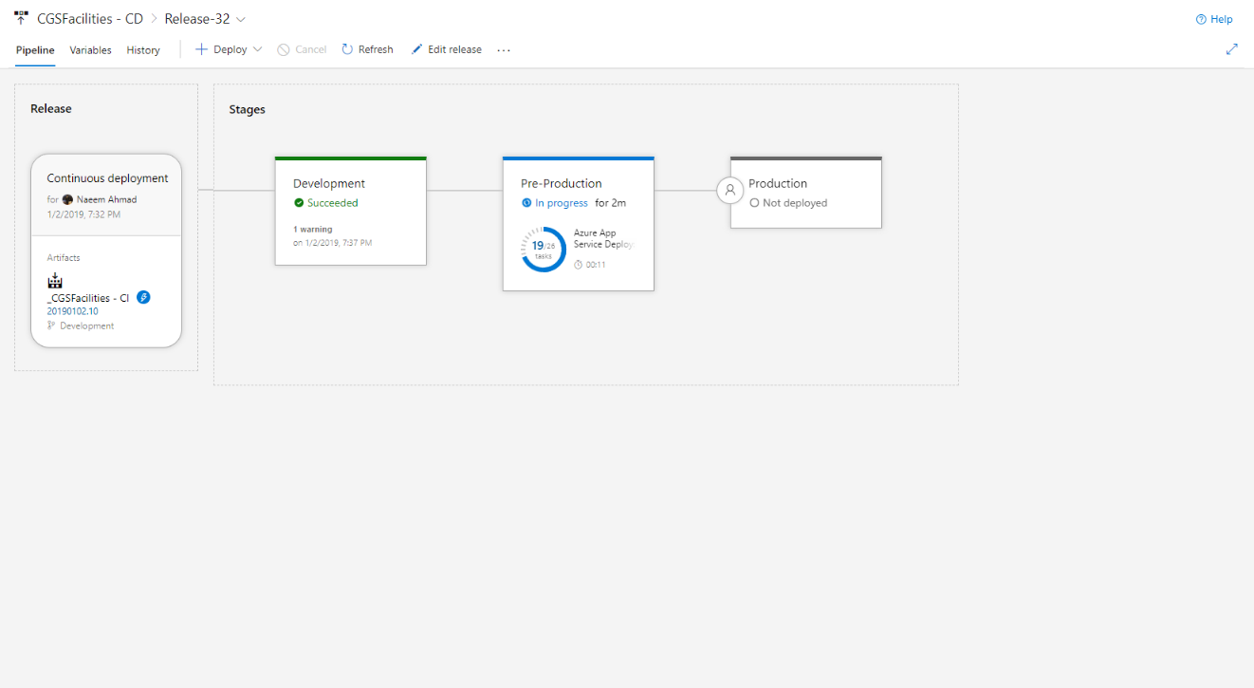

**PreProduction**

It will trigger automatically and wait for approval after **Development** stage complete, After approved by admin or approvers it’ll deployed in below mentioned urls:

<http://preprod-customer-cgsservices.azurewebsites.net>

<http://preprod-client-cgsservices.azurewebsites.net>

<http://preprod-provider-cgsservices.azurewebsites.net>

<http://preprod-api-cgsservices.azurewebsites.net>

<http://preprod-scheduler-cgsservices.azurewebsites.net>

<https://preprod-auth-client-cgsservices.azurewebsites.net>

<https://preprod-auth-customer-cgsservices.azurewebsites.net>

<https://preprod-auth-provider-cgsservices.azurewebsites.net>

[https://preprod-pm-cgsservices.azurewebsites.net](http://preprod-pm-cgsservices.azurewebsites.net/)

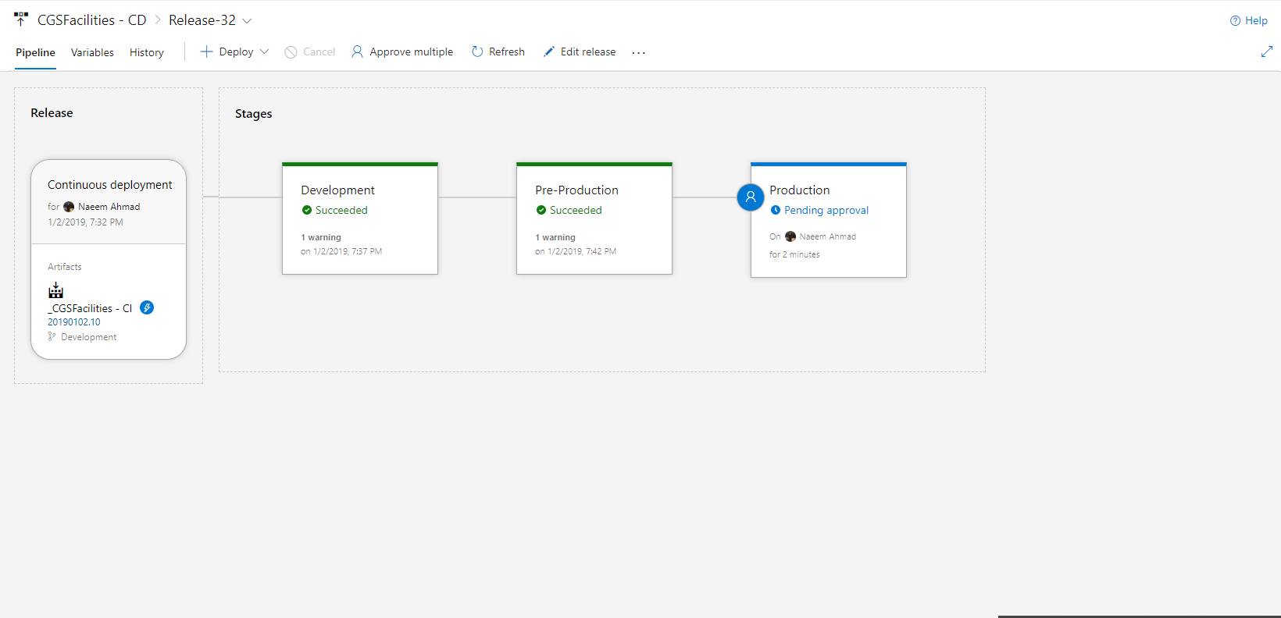

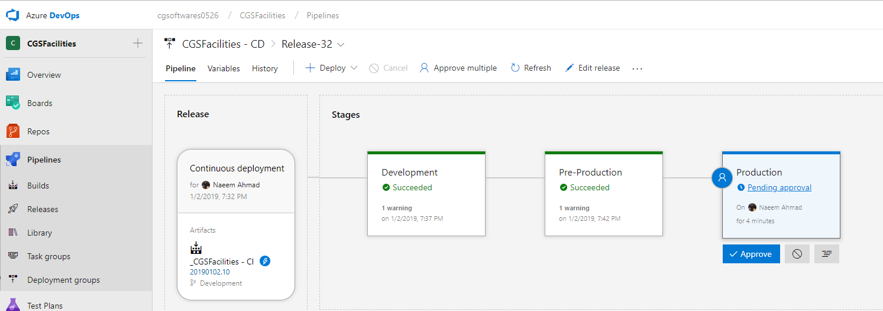

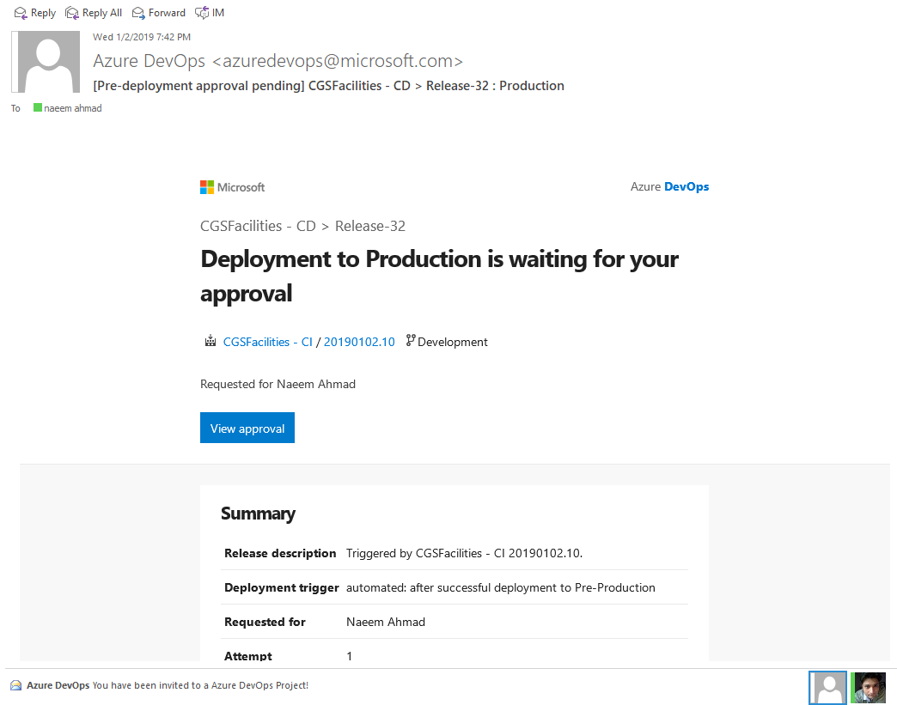

**Production**

It will trigger automatically and wait for approval after **PreProduction** stage complete, After approved by admin or assigned approvers it’ll deployed in below mentioned urls:

<http://prod-customer-cgsservices.azurewebsites.net>

<http://prod-client-cgsservices.azurewebsites.net>

<http://prod-provider-cgsservices.azurewebsites.net>

<http://prod-api-cgsservices.azurewebsites.net>

<http://prod-scheduler-cgsservices.azurewebsites.net>

<https://prod-auth-client-cgsservices.azurewebsites.net>

<https://prod-auth-customer-cgsservices.azurewebsites.net>

<https://prod-auth-provider-cgsservices.azurewebsites.net>

<https://prod-customer-cgsservices.azurewebsites.net>

<https://prod-client-cgsservices.azurewebsites.net>

<https://prod-provider-cgsservices.azurewebsites.net>

[https://prod-pm-cgsservices.azurewebsites.net](http://dev-pm-cgsservices.azurewebsites.net/)